Visual Studio Team Services Lab Prerequisites

Lab version: 15.7.3

Last updated: 6/6/2018

1. **TABLE OF CONTENTS**

Overview 1

Prerequisites 1

Exercise 1: Configuring the Parts Unlimited team project 1

Task 1: Configuring the Parts Unlimited team project 1

Task 2: Configuring the Parts Unlimited solution in Visual Studio 2

# Overview

Certain Visual Studio Team Services labs require a preconfigured **Parts Unlimited** team project. This document outlines the required steps to set up the required data.

## Prerequisites

* Visual Studio Team Services (VSTS) account (<https://www.visualstudio.com/team-services>)
* Visual Studio 2017 (if specified in lab)

# Exercise 1: Configuring the Parts Unlimited team project

## Task 1: Configuring the Parts Unlimited team project

1. Navigate to <https://vstsdemogenerator.azurewebsites.net>.
2. Sign in using the Microsoft account associated with your VSTS subscription.
3. **Accept** the permission requests for accessing your subscription.
4. Use the project name **“Parts Unlimited”** and select the **PartsUnlimited** template. Click **Create Project**. Wait for the process to complete.

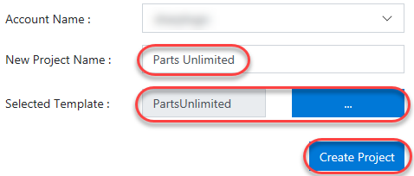

## Task 2: Configuring the Parts Unlimited solution in Visual Studio

1. Some labs will require you to open the **Parts Unlimited** solution in **Visual Studio**. If your lab doesn’t require this, you can skip this task.
2. Navigate to your VSTS team project for **Parts Unlimited**. It will be something like <https://YOURACCOUNT.visualstudio.com/Parts%20Unlimited>.
3. Navigate to the **Code** hub.

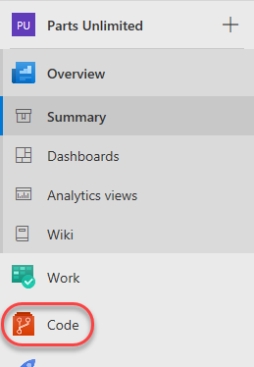

1. Click **Clone** and select **Clone in Visual Studio**.

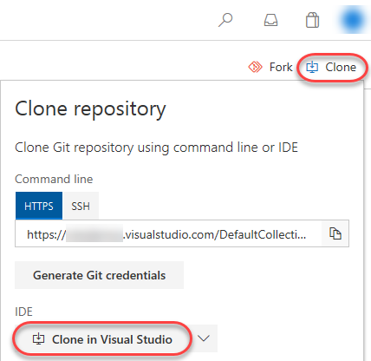

1. Follow the workflow to clone and configure the project in Visual Studio. Click **Clone** to copy the repo locally.

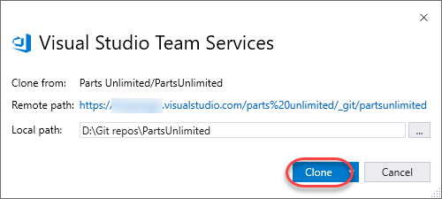

1. From **Solution Explorer**, double-click **PartsUnlimited.sln** to open the solution. You can ignore warnings about unsupported project types.

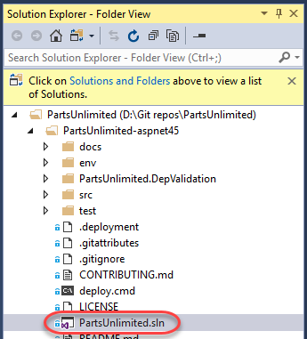

1. Leave Visual Studio open for use in your lab.